Ty Marking

Mr. Risse

Period 4

1 June, 2018

Seeing Physics

**Personal Engagement**

One of my first existential questions I remember having is what if how the color red looks to me is not how it looks to other people? We call it the same thing, we describe it the same way, we all know that it is red, but do we really see the same thing? Maybe how another person’s mind interoperates that particular wavelength of light is how my mine interoperates the wavelength for, say, green. Ever since then I have had an interest in how light works and as I have learned more about the physics of light, the more curious I became. One quite interesting aspect of light is how it interacts with polarization filters. Most everything about light’s interactions with polarization filters isn’t perfectly intuitive. For example, I learned that polarization filters are composed of long polymers all orientated in the same direction, not unlike the bars of a prison window. Following intuition, you’d imagine that light orientated parallel to the polymers would slip through like paper slipping through a jail window. But it’s the opposite. Light orientated the same direction as the polarization filter is absorbed by the polymers and light perpendicular to them is let through. Except even that isn’t quite right, non-perfectly angled light isn’t completely absorbed or let through. Polarization isn’t a binary operation. And to see how and retrain my intuition, I experimented with light and polarization filters.

**Research Question**

How is the intensityof light passing through two polarization filters affected by changing the relative orientation of the filters?

This question will be tested by having a focused light source pointing at a digital light sensor. Between the light emitter and sensor will be two polarization filters mounted in a way that they can be rotated to set degrees. These filters will block some of the light and that difference will be measured by the digital light sensor.

**Background**

The question of what light is and how and why it behaves has been central to much of the development of physics. Light has properties of both waves and particles and it is often treated as one or the other depending on the situation. In the case of polarization filters, it is helpful to think of light as a wave. In reality is closer to two waves perpendicular to both each other and the direction of the light, but for my purposes with polarization filters thinking of light as a single wave will be sufficient.

From my background knowledge, I predict that when the two polarization filters are orientated in the same direction the most light will pass through and when they are rotated 90 (or 270) degrees from each other they will let through next to none light. Between those degrees, I expect the intensity of light let through to follow a sinusoidal pattern, increasing slowly from 0 degrees, increasing quickly at 45 degrees and then back to increasing slowly closer to 90 degrees. From 90 to 180 degrees I expect the same relation except with the intensity of light decreasing instead of increasing. For degrees after 180 I expect the light to behave the same as it does at the degree difference minus 180.

As already mentioned, polarization filters can be thought of to work like jail windows or bars in a cage except with light being absorbed when parallel to the polymers

and let through when perpendicular. However, if polarization filters only let through light that is perfectly perpendicular to the orientation of the polymers, then having two filters that are orientated differently even slightly would not let any light through. From even a cursory look at two polarization filters, it is clear that the amount of light being let through is a gradual change and not like to opaque disks with a slot cut in them that only lets light through when they are aligned perfectly.

What is happening is when light is not perfectly polarized (or orientated) parallel or perpendicular to the filter, the component of the light in the orientation that the filter lets through is still let through. This diminishes the intensity of the photon, but some energy is still let through. All the light passing through the filter is now polarized, the waves are perpendicular to the direction of the polymers of the polarization filter. The intensity is not as high, but all the light is orientated in the same direction.

When a second filter is added, if it is in the same orientation as the first filter all the light will pass through because it has already been polarized into the orientation of the filters. When the second filter is rotated 90 degrees from the first filter, all the light will be absorbed because it is all in the same direction as the polymers in the second filter. This is the reason for the 0 and 90 degree cases in my hypothesis.

Between a 0 and a 90 degree offset, the second filter is once again only letting through the component of the light wave that is perpendicular to its polymers. The quantity of this component is dependent on the sin/cosine of the angle just as any component is. This is why I predict a sinusoidal relationship between the angle offset and the intensity of light let through.

**Variables**

|  |  |  |
| --- | --- | --- |
| **Variable** |  | ***How is it measured?*** |
| **Manipulated** | **Difference in orientation of polarization filters** | Both polarization filters were circular and marked every degree. The degree of each polarization filter was measured by aligning the wanted angle with the edge of a vertical indicator consisting of a thin coffee stirrer. The coffee stirrers were aligned vertically using a plumb line and held in place by tape for the duration of the experiment without any interferences. |
| **Responding** | **Intensity of light passed through both filters** | The intensityof light that passed through both filters was measured by a digital light sensor that was fixed in place on the back of the apparatus by tape and held without interference for the entire duration of the experiment. The light sensor I used, an Extech Light Meter, has two modes. One has a range of 200 foot candles and measured down to 0.1 foot candles and the other mode has a range of 2000 foot candles and measures down to 1 foot candle. I used the later mode as at the very peak the measured light was greater than 200 foot candles. |
| **Controlled**  **Controlled**  **(continued)** | **Initial light intensity**  **Distance between all instruments**  **Distance between all instruments**  **(continued)**  **Ambient Light** | The spotlight used to emit the initial light was powered by a controllable power source that was not adjusted for the entirety of the experiment. The spotlight itself was not touched or moved or otherwise interfered with during the experiment  The distances between the spotlight, the two polarization filters, and the digital light sensor were fixed through the use of a custom made mounting structure. This structure looks like the lowercase letter “h” but greatly stretched horizontally.  The digital light sensor was first taped to its box and then taped against the back wall, the tall part of the “h”. The box was included to move the light sensor closer to the spotlight to decrease the spread of the light and increase the accuracy of the data.  The polarization filters were mounted inside custom made holders that secured them while allowing them to rotate. Each filter was placed in a cardboard rectangle that had a circle cut out to fit the filter and these were each placed between two more cardboard rectangles which had a smaller square cut out that allowed the light to pass through while holding the filters in place. Both three layer holders were taped shut to form two tasty polarizing cardboard sandwiches. Two right angle brackets were then attached to the bottom of the holders and were taped down onto the bed of the mounting structure, the elongated horizontal part of the “h”.  The spotlight was placed up against the front wall of the mounting structure, the right leg of the “h”, and pointed at the center of the digital light sensor. It was kept in place and not moved during the experiment.  Outside light interference was controlled by performing the experiment in a nearly dark room. The only other light beside the spotlight was from a second, much dimmer, spotlight not pointed at the experiment that was used to read the output of the light sensor and record the data. The output of the light sensor did not change when this second spotlight was turned off and on even when the polarization filters were orientated so that the light sensor was reporting -1 foot candles. Furthermore, even when the door to the room was open, the sensor did not change. Even so, the experiment was only performed when the door was closed and with the second spotlight being at a constant intensity. |

**Apparatus and Materials**

* Extech Light Meter (range of 2,000 foot candles with precision down to ±1 foot candle)
* Light Meter box.
* Spotlight with a diameter of 3.3 cm at a 20 cm range capable of producing over 200 foot candles of light.
* Controllable power supply.
* Two circular polarization filters with marked angles in degrees.
* Cardboard to hold polarization filters.
* 4 wide right-angle brackets and 4 rubber bands to hold carboard mounts up.
* 3.5 cm thick Scotch 3M tape.
* 3 pieces of 10 cm wide wood, one 8cm long, one 25 cm long, and one 38 cm long.
* Two long right-angle brackets and 8 short nails to connect the wood.
* Two short coffee stirrer sticks to measure the angle on the polarization filters.
* A plumb line to orientate the coffee stirrers to vertical.

**Diagram**

Mounting Structure

Coffee stirrer sticks

Polarization Filter

Spotlight

Carboard Filter Holders

Wide Right-Angle Brackets And Rubber Bands

Wooden Mounting Structure

Light Meter

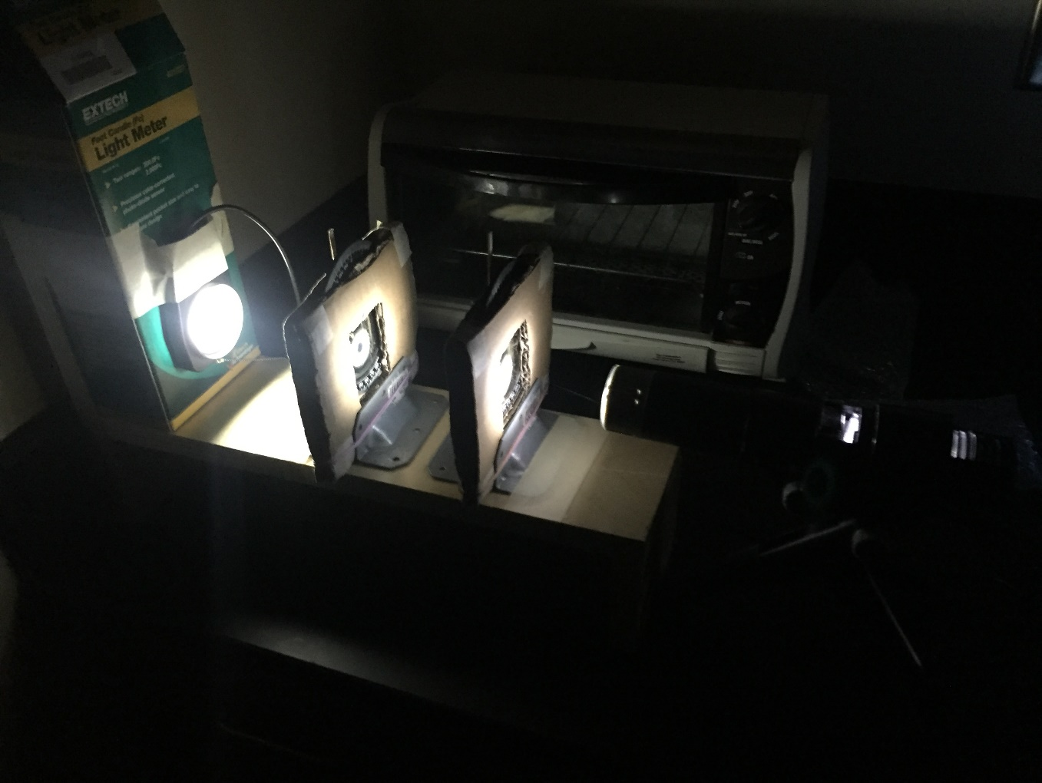

**Safety**

Do not look directly into the light.

**Procedure**

1. Assemble the mounting structure by attaching the 8cm long plank of wood under one end of the 38 cm plank using the long right-angle brackets and short nails and then attaching the resulting structure a vertical 25cm long plank to form an elongated “h” structure.
2. Assemble the filter holders by placing the polarization filters inside a cardboard rectangle cut out to fit the filters with the top of the filter showing to read the angle markers. Place that between two identical cardboard rectangles that have a square cut out of the middle to let light through.
3. Place a wide right-angle bracket on either side of both carboard-filter sandwiches and place two rubber bands around each filter holder and brackets to hold the brackets onto the filter holders.
4. Using a plumb line to ensure they are orientated vertically, attach a coffee stirrer stick to the top center of both filter holders and align the filters so that their zero-degree mark lines up with the vertical coffee stirrer sticks.
5. Place the filter holders onto the bed of the mounting structure and tape the bottom part of the right-angle brackets to the mounting structure to hold the filter holders in place.
6. Position the spotlight against the front of the mounting structure and orientate it so that it emits light straight through both filters.
7. Plug in the power supply to a wall outlet and the spotlight to the power supply. Turn on the power to the spotlight.
8. Tape the box of the light sensor to the back wall of the mounting structure and to that tape the light sensor so that the light from the spotlight hits the center of the sensor.
9. Turn off the lights and make sure any ambient light sources are not affecting the sensor.
10. Rotate the first filter from 0 degrees all the way around stopping every 10 degrees to record the output of the light sensor. Use the vertical coffee stirrer sticks to read the angle of the filter. Make sure to press down the filter holder so that it does not move when you rotate the filter. If it is constructed correctly the filter should be able to rotate freely inside the holder.
11. After rotating the filter all the way around collecting data every 10 degrees, start again and repeat the process for each trial. Record as many trials as possible.

**Data**

**Intensity of light passing through two differently orientated polarization filters**

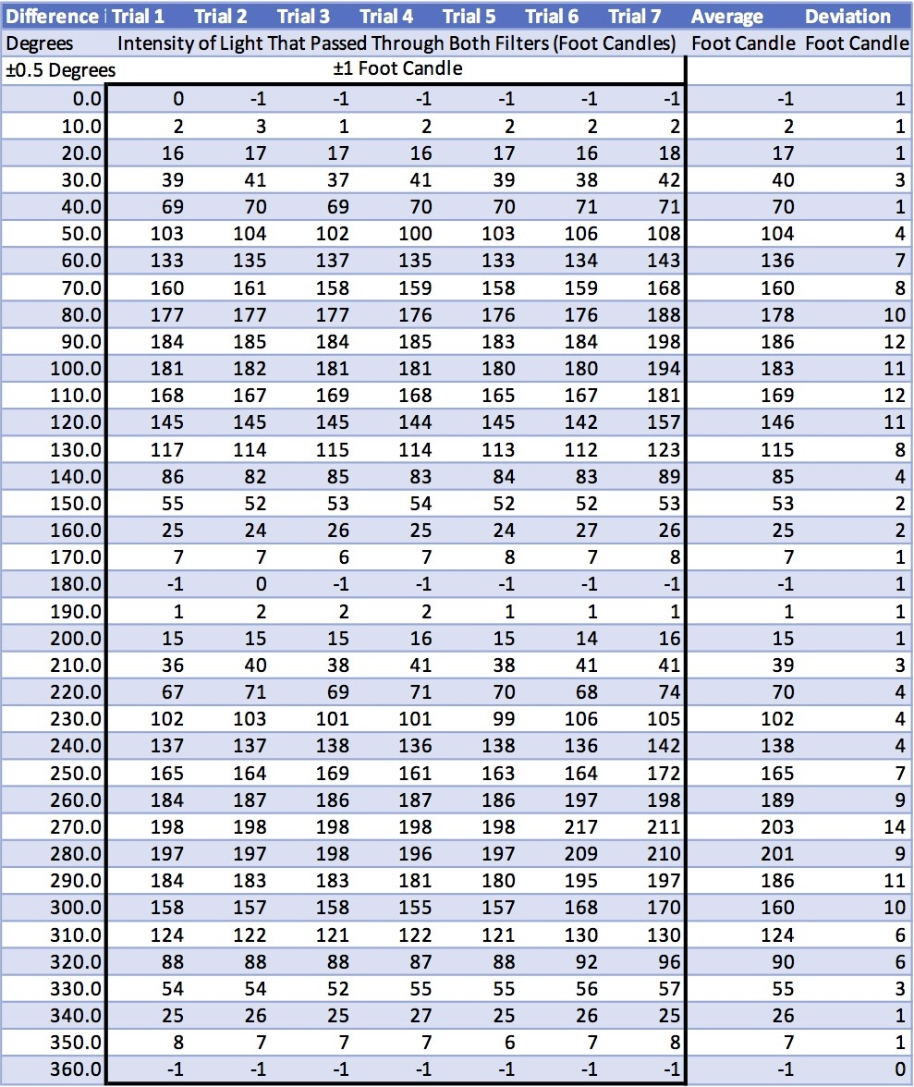

The raw data from my experiment can be seen above. Data was collected every 10 degrees of delta orientation from 0 to 360 degrees for 7 trials. I did collect more data with the light sensor in the 0.1 foot candle precision mode but in that mode, the sensor was later maxed out as it had a limit of 200 foot candles. The readings from the same situation in both 1 and 0.1 foot candle precision modes were significantly different meaning that the data collected in the more precise mode had to be thrown out.

When the two filters were aligned to block the most amount of light (every 180 degrees), the light sensor reported an intensity of -1 foot candles even though visually it appeared as though a small amount of light was passing through both filters and hitting the sensor. Turning off the spotlight did not change the -1 foot candle reading.

The difference between the two precision modes and the negative reading leads me to distrust the actual magnitude of the intensity readings; however, the actual magnitude of the data and the resulting amplitude of the sinusoidal model are irrelevant. I am studying the relative intensity of light that passed through both filters and if I had used a spotlight that emits twice as many foot candles or half as many it would not have any effect on my conclusion. As long as the sensor is consistent, a small constant deviation from the actual value is insignificant.

Looking at the raw data, at around the mid 200 degree differences on the 6th trial, the data breaks from its previous consistency and starts to read around 10 foot candles higher than previous tests. This difference decreases as the degree difference approaches a multiple of 180 degrees as does the magnitude of the data. This consistent inconsistency continues through the 7th trial. If the data is analyzed without the 6th and 7th trials, the maximum deviation (besides one errant deviation of 5 foot candles resulting from an outlier) is 2 foot candles, about 1% of the maximum value. With the 6th and 7th trials factored in there is one deviation at 14 foot candles and the two more at 12 foot candles. This leads me to believe that in the 6th trial between the 250 and 260 degree difference mark, something permanently interfered with the experiment causing it to report a higher intensity. At the time, I did not notice anything that could have been the source of this interference; however, even with the interference, the data is still relatively consistent.

**y = -99.88cos(114.99x – 0.09) + 99.79**

Graphing the data, we can see two clear periods of a sinusoidal function. The second period has a higher peak but the same minimum. I believe this difference was caused by imperfections such as scratches and marks in the polarization filter that blocked light no matter its orientation. Many such imperfections are visible on the filters. As the filter rotated, the spot on the filter that light passed through slightly changed so the quantity and size of the imperfections changed.

Due to the different periods having slightly different amplitudes, the sinusoidal model deviates slightly from the experimental data towards the peaks. On the next page are both periods graphed independently with their own unique sinusoidal model that fits the data near perfectly.

All the sinusoidal models were generated with a python script using gradient descent with a mean squared error cost function. I am confident that a technically more accurate and precise model could be developed but any level of precision beyond that presented here would fall victim to overfitting the model to the data. My choice to include more significant figures in my model was because, especially within the cosine function, rounding away the hundredths place caused a noticeable and significant change in the accuracy of the model.

**y= -94.4cos(-112.91x +0.01) + 92.24**

**y= -100.44cos(-114.59x +0.11) + 98.24**

**Conclusion**

The experimental data follows a sinusoidal pattern with a period of 180 degrees as I predicted in my hypothesis. However, the maximum of light occurred at 90 and 270 degree offsets where I predicted them to be at 0 and 180 degree offsets. According to theory, a second polarization filter with the same orientation as a first filter should not block any additional light or reduce its intensity in any way. What I don’t have any guarantee of is if the degree markings on the two filters are in the same positions relative to the orientation of their filters. It is entirely possible that when one filter is at 0 degrees and one is at 90 degrees that they are orientated in the same direction.

Besides the uncertainty of the initial orientation, the data suggests that the intensity of light let through two differently orientated polarization filters does follow a sinusoidal relationship with a period of 180 degrees, a vertical shift of half the amplitude, and that 180 degrees to 360 degrees is the same as 0 degrees to 180 degrees. The amplitude itself and the phase shift are situationally based and therefore irrelevant to the model. My hypothesis is supported by this data.

**Limitations to Conclusion**

The biggest limitation to my certainty of my conclusion arises from the suspected interference partway through trial 6; however, even with those trials counted, I am very confident with my results. There is also the potential issue of the light sensor being inaccurate as it reads significantly different light levels in different precision modes and read a negative value in many instances. However, since the intensity is only important relative to itself and there is no indication that the light sensor had a non-linear skew, I do not believe it interferes with the conclusion. My results match what the theory says should happen (when accounting for a 90 degree difference in labeled orientation between the two filters) and the data is overall very consistent. All sinusoidal models generated fit within the error bars of the graphs, and when the two periods are considered separately to account for local imperfections in the filters, the experimental data matches almost exactly with the sinusoidal model.

|  |  |
| --- | --- |
| **Limitations to Procedure** | **Suggestions for Improvement** |
| The biggest limitation to this experiment is the source of the discrepancy that occurred starting in trial 6. This discrepancy is unknown but has a few likely causes, namely an accidental and unrealized bump of the spotlight or sensor or the holders of the filters. | Screwing in the filter holders would prevent them from being moved. Like I did for the filters, constructing a holding mount that could be firmly attached to the mounting apparatus for both the spotlight and the light sensor would help prevent them from being accidentally moved during the experiment and would allow for the experiment to be conducted over several days allowing for more trials and more data. |
| The two periods of the data had slightly different maximums. I believe this to be caused by impurities such as scratches or marks on the filters themselves that are only in the circle of light during some parts of the rotation. | There are two ways to improve this limitation. The first is to use new filters that do not have visible marks. The second to ensure that the spotlight is pointed directly at the center of the filters so that any impurities present will be present for the entire duration of the experiment. A combination of both would likely yield the best results. |
| A third limitation to the procedure arises from the uncertainty of the validity of the light sensor used. It read a negative value in multiple instances and had a significant discontinuity between its precision modes. | The simple answer to this limitation is to use a different light sensor that has been validated to have no non-linear skews. As stated before a bias in the amplitude is irrelevant as long as the data is accurate relative to the other points of data. Using the more accurate sensor mode would also help improve the accuracy of the data but this would require using either a less powerful spotlight or turning down the power supply. Turning down the power supply has the disadvantage that it would be easy for the knob to be turned and it would be much harder to return the knob to its initial position than if the knob was set at the maximum position. |